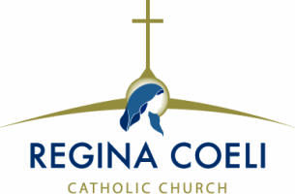
April 18, 2021
Dear Parents,
It’s time to make a decision about your child’s Religious Education for next school year. Although YOU have the primary responsibility of passing on your faith to your children, CCD classes help you with this responsibility. Through prayer, study and class discussion children have the opportunity to
grow in their knowledge and love of God and of the Catholic Faith.
Our CCD Program is open to all Catholic children in grades 1 – 8 who are not attending a Catholic elementary school. In-person classes are held on Sunday morning from 9:00 am – 10:15 am. in school classrooms. Because of the Covid virus, we provided home study lessons last year. However, with
the availability of vaccines and the return to in-person classes at public schools home study will NOT be provided for the 2021 – 2022 year. Children need to receive instruction from teachers, pray together, take part in class discussion and be part of a Catholic learning community. This cannot happen at home.
We had a safe, successful year of in-person classes this year and look forward to another year of safe classes.
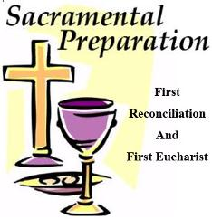
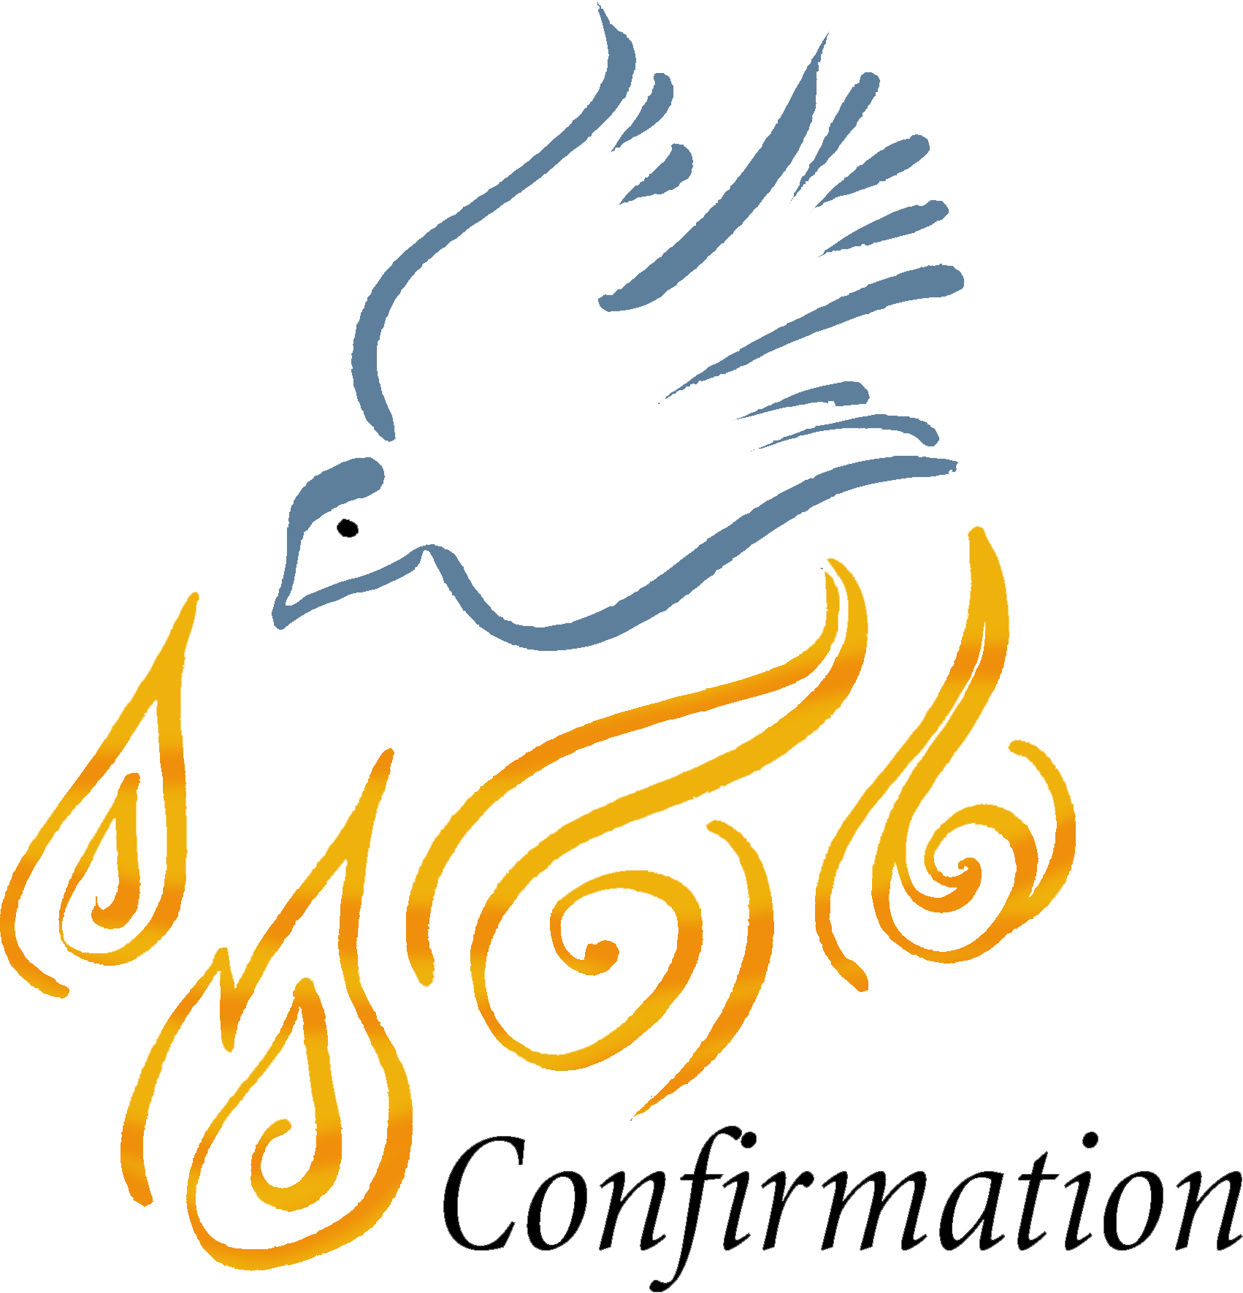
SACRAMENTAL PREPARATION ~ TWO YEARS LONG

Children in Grade 2 receive the Sacraments of First Reconciliation and First Holy Communion and young people in Grade 8 receive the Sacrament of Confirmation. These students need more than one year of preparation before they receive their sacrament(s). Our parish policy
is that children must attend both First and Second Grade CCD classes to receive First Reconciliation and First Holy Communion and Seventh and Eighth Grade CCD classes to receive Confirmation.

Please inform parents in your family and neighborhood whose children are not yet enrolled in our CCD Program that now is the time to register for next September. New families may register by completing the attached Registration Form, by calling the CCD Office at 419-476-0922 or by sending an email to rc3ccd@gmail.com. A Registration Form will be send electronically when requested.
Although classes won’t begin until the first of September, textbooks for next year will be ordered during May so it is important to have children soon so we have books and supplies ready for them when classes begin.

The opening CCD class for next year will be on
Sunday, September 12, 2021.

